An Interdisciplinary Project Report

on

Deep Q-Network-Based Relay Selection For Efficient Routing In Underwater Wireless Sensor Networks
Submitted to

JAWAHARLAL NEHRU TECHNOLOGICAL UNIVERSITY ANANTAPUR, ANANTHAPURAMU

In Partial Fulfillment of the Requirements for the Award of the Degree of

BACHELOR OF TECHNOLOGY

in

COMPUTER SCIENCE & ENGINEERING ( DATA SCIENCE )

Submitted By

NAME | ROLL NO.
CHILAMAKURU VARSHINI | 23691A32H7
BANA VAMSEE | 23691A32H3
JAGADAM SUMANTH | 23691A32F6
BIJIVEMULA THRISHA | 23691A0255

Under the Guidance of
Mr.G.Kiran Kumar. M.Tech.,(Ph.D)
Asst. Professor
Department of Computer Science & Engineering ( Data Science )


MADANAPALLE INSTITUTE OF TECHNOLOGY & SCIENCE
(UGC – AUTONOMOUS)

(Affiliated to JNTUA, Ananthapuramu)
(Accredited by NBA, Approved by AICTE, New Delhi)
AN ISO 21001 : 2018 Certified Institution
- B. No: 14, Angallu, Madanapalle – 517 325
2023-2027


DEPARTMENT OF COMPUTER SCIENCE & ENGINEERING
( DATA SCIENCE )

BONAFIDE CERTIFICATE

This is to certify that the project work entitled “Deep Q - Network - Based Relay Selection for Efficient Routing in Underwater Wireless Sensor Networks” is a bonafide work carried out by

NAME | ROLL NO.
CHILAMAKURU VARSHINI | 23691A32H7
BANA VAMSEE | 23691A32H3
JAGADAM SUMANTH | 23691A32F6
BIJIVEMULA THRISHA | 23691A0255

Submitted in partial fulfillment of the requirements for the award of the degree Bachelor of Technology in the stream of Computer Science & Engineering ( Data Science ) in Madanapalle Institute of Technology & Science, Madanapalle, affiliated to Jawaharlal Nehru Technological University Anantapur, Ananthapuramu during the academic year 2025-2026.

Guide | Head of the Department
Mr. G. Kiran Kumar, M.Tech.,(Ph.D) | Dr. S. Kusuma, Ph.D
Assistant Professor | Assistant Professor & Head
Department of Computer Science & Engineering ( Data Science ) | Department of Computer Science & Engineering ( Data Science )

ACKNOWLEDGEMENT

We sincerely thank the Management of Madanapalle Institute of Technology & Science for providing excellent infrastructure and lab facilities that helped us to complete this project.

We sincerely thank Dr. R. Ramanathan, Ph.D., Principal for guiding and providing facilities for the successful completion of our project at Madanapalle Institute of Technology Science, Madanapalle.

We express our deep sense of gratitude to Dr. S. Kusuma., Ph.D., Assistant Professor and Head of the Department of CSE - Data Science for her continuous support in making necessary arrangements for the successful completion of the Project.

We express our deep sense of gratitude to Mr. G. Rajkumar.M.Tech.,(Ph.D), Project Coordinator, for his valuable guidance and encouragement that helped us to complete this project.

We express our deep gratitude to our guide Mr. G. Kiran Kumar.M.Tech.,(Ph.D), Assistant Professor, Department of CSE - Data Science for his guidance and encouragement that helped us to complete this project.

We also wish to place on record my gratefulness to other Faculty of the CSE - Data Science Department and also to our friends and our parents for their help and cooperation during our project work.

Abstract
In the domains of ocean exploration, underwater environment monitoring, and underwater navigation target tracking, underwater wireless sensor networks (UWSNs) have become increasingly significant. The intricacy of the undersea environment presents numerous difficulties for sensor node positioning in WSNs, which are dynamic networks. Because of the hostile underwater environment, acoustic transmissions are employed in place of radio signals to carry data from source to destination. It has sensor nodes that detect data and transmit it to a central node known as a sink node. The battery life of the sensor nodes is limited. In the aquatic environment, the sensor's battery cannot be changed. Hotspot problems are brought on by data forwarding to the closest sensor nodes, and early energy depletion results in network failure. The current study employs cooperative strategies to achieve sink mobility and reliability, which lowers energy usage by eliminating hotspot problems. The routing protocols are used to determine the relay path. It operates on distance-based and static energy thresholds. The most effective relay path is not provided by it. It depends on preset rules, and in large-scale networks, performance deteriorates. Relay selection in the suggested study is done using the Deep Q-Network Machine Learning approach. It takes into account a number of variables to determine the best relays. By discovering the best relay patterns, it balances the node's energy and prolongs the network's lifespan. DQN is also adaptable to shifting node locations. It lowers transmission loss, adapts to changing conditions, and displays the optimal relay path in large-scale networks. The suggested findings improve UWSNs' general dependability and efficiency.
Keywords: Network lifetime, packet delivery ratio, transmission loss, energy usage, and deep-Q-network.



MADANAPALLE INSTITUTE OF TECHNOLOGY & SCIENCE
(UGC-AUTONOMOUS INSTIUTION)
Affiliated to JNTUA, Ananthapuramu & Approved by AICTE, New Delhi NAAC
Accredited with A+ Grade, NIRF India Rankings 2025 - Band: 201-300 (Engg.)
NBA Accredited - B.Tech. (CIVIL, CSE, CST, ECE, EEE, MECH), MBA & MCA

RECOGNISED RESEARCH CENTER

Plagiarism Verification Certificate

This is to certify that the B. Tech Project report titled, “Deep Q-Network-Based Relay Selection For Efficient Routing In Underwater Wireless Sensor Networks” submitted by Chilamakuru Varshini (23691A32H7), Bana Vamsee (23691A32H3), Jagadam Sumanth (23691A32F6), Bijivemula Thrisha (23691A0255) has been evaluated using Anti- Plagiarism Software, Turnitin and based on the analysis report generated by the software, the report’s similarity index is found to be 9 %.

The following is the Turnitin report for the project report consisting of 47 pages.
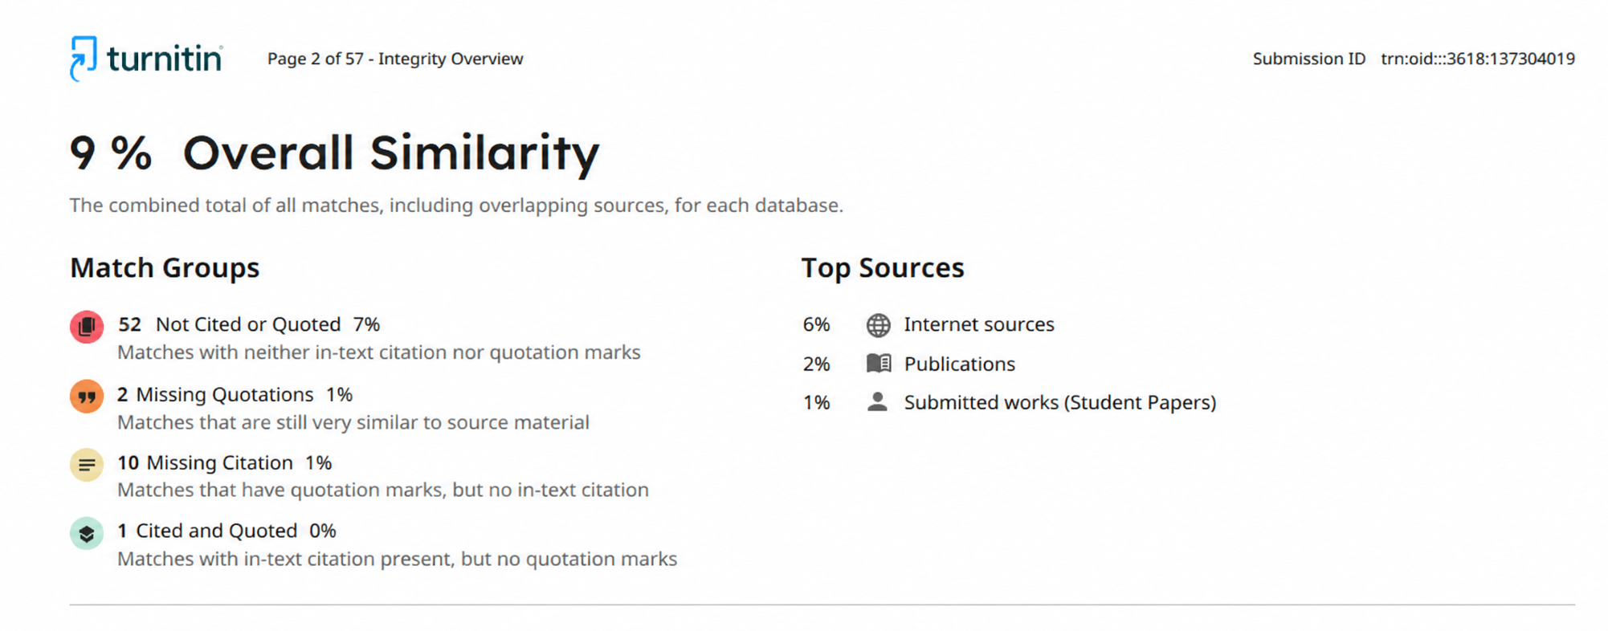

DECLARATION

We hereby declare that the results embodied in this project “Deep Q-Network-Based Relay Selection For Efficient Routing In Underwater Wireless Sensor Networks” by us under the guidance of Mr. G. Kiran Kumar .M.Tech.,(Ph.D), Assistant Professor, Department of CSE - Data Science in partial fulfillment of the award of Bachelor of Technology in Computer Science & Engineering ( Data Science ) from Jawaharlal Nehru Technological University Anantapur, Ananthapuramu and we have not submitted the same to any other University/institute for the award of any other degree.

Date:

Place:

PROJECT ASSOCIATES
Chilamakuru Varshini
Bana Vamsee
Jagadam Sumanth
Bijivemula Thrisha

I certify that the above statement made by the students is correct to the best of my knowledge.

Date: Guide:

INDEX

S.NO | TOPIC | PAGE NO.
1. | INTRODUCTION | 1
 | 1.1 MOTIVATION | 1
 | 1.2 PROBLEM DEFINITION | 2
 | 1.3 OBJECTIVE OF THE PROJECT | 3
 | 1.4 LIMITATIONS OF PROJECT | 3
 | 1.5 ORGANIZATION OF DOCUMENTATION | 4
2. | LITERATURE SURVEY | 6
 | 2.1 INTRODUCTION | 7
 | 2.2 EXISTING SYSTEM | 7
 | 2.3 DISADVANTAGES OF EXISTING SYSTEM | 11
 | 2.4 PROPOSED SYSTEM | 12
 | 2.5 ADVANTAGES OVER EXISTING SYSTEM | 12
3. | ANALYSIS | 14
 | 3.1 INTRODUCTION | 15
 | 3.2 REQUIREMENT SPECIFICATIONS | 15
 | 3.2.1 HARDWARE REQUIREMENTS | 15
 | 3.2.2 SOFTWARE REQUIREMENTS | 16
 | 3.3 CONTENT DIAGRAM OF PROJECT | 16
4. | DESIGN | 17
 | 4.1 INTRODUCTION | 18
 | 4.2 UML DIAGRAM | 18
 | 4.3 SYSTEM ARCHITECTURE | 19
 | 4.4 MODULE DESIGNING AND ORGANIZATION | 20
 | 4.5 DQN-BASED RELAY SELECTION | 21
 | 4.6 LEARNING AND OPTIMIZATION PROCESS | 22
 | 4.7 SYSTEM WORKFLOW | 22
5. | IMPLEMENTATION AND RESULTS | 23
 | 5.1 INTRODUCTION | 24
 | 5.2 IMPLEMENTATION OF KEY FUNCTIONS | 24
 | 5.3 METHOD OF IMPLEMENTATION | 24
 | 5.4 RESULT ANALYSIS AND DISCUSSION | 25
6. | TESTING | 29
 | 6.1 INTRODUCTION | 30
 | 6.2 LEVELS OF TESTING | 30
 | 6.3 VALIDATION TESTING | 30
 | 6.4 CONCLUSION | 30
7. | CONCLUSION | 31
 | 7.1 CONCLUSION | 32
 | 7.2 FUTURE ENHANCEMENT | 32
8. | REFERENCES | 33
 | 8.1 REFERENCES | 34

LIST OF FIGURE
- No. | Figure | Page No.
1 | 2.1: Communication in UWSNs | 8
2 | 2.2: Flowchart for Communication | 9
3 | 3.3 Content Diagram of Project | 16
5 | 4.2 UML Diagram | 18
6 | 4.3 System Architecture | 19
7 | 4.5 DQN-BASED Relay Selection | 21
8 | 5.4 Result Analysis and Discussion | 25
9 | 5.4.1 Comparison of Average Alive Nodes | 25
10 | 5.4.2 End to End Delay Analysis | 26
11 | 5.4.3 Transmission Loss Analysis | 27

LIST OF ABBREVIATIONS

S.NO. | ABBREVATION | ABBREVIATION NAME
1 | UWSN | UNDERWATER WIRELESS SENSOR NETWORKS
2 | DQN | DEEP Q-NETWORK
3 | RL | REINFORCEMENT LEARNING
4 | AI | ARTIFICIAL INTELLIGENCE
5 | ML | MACHINE LEARNING
6 | CEER | COOPERATIVE ENERGY-EFFICIENT ROUTING
7 | EELRP | ENERGY-EFFICIENT LOCALIZATION ROUTING PROTOCOL
8 | EEDORVA | ENERGY-EFFICIENT DEPTH-BASED OPPORTUNISTIC ROUTING
9 | BER | BIT ERROR RATE
10 | SNR | SIGNAL-TO-NOISE RATIO
11 | PDR | PACKET DELIVERY RATIO

CHAPTER 1
INTRODUCTION

INTRODUCTION
A new technology called Underwater Wireless Sensor Networks (UWSNs) makes it possible to communicate and gather data in underwater environments such rivers, lakes, seas, and oceans. These networks are made up of several sensor nodes that are placed underwater to keep an eye on physical and environmental factors like salinity, temperature, pressure, pollution, and marine activity. UWSNs are crucial for applications including maritime exploration, catastrophe avoidance, and environmental monitoring.
Because of the particular underwater environment, UWSNs confront a number of difficulties that terrestrial wireless networks do not. These networks primarily use auditory communication since radio frequency signals cannot effectively propagate in water. Acoustic signals include drawbacks such high latency, constrained bandwidth, and signal attenuation even if they enable long-distance transmission. Furthermore, energy efficiency is a crucial component of network performance since sensor nodes run on batteries that are challenging to replace underwater.
In UWSNs, routing is essential since the gathered data needs to be effectively sent to a base station or sink node. Because they rely on set rules and are unable to adjust to changing circumstances, traditional routing protocols are not appropriate for dynamic underwater environments. This article suggests a Deep Q-Network (DQN)-based relay selection method to get around these problems. Reinforcement learning allows the system to dynamically choose the best relay nodes depending on energy, distance, and network circumstances, increasing network longevity, efficiency, and dependability.
1.1 MOTIVATION
Applications such as ocean research, environmental monitoring, catastrophe warning, offshore exploration, and military use are making Underwater Wireless Sensor Networks (UWSNs) increasingly significant. These networks are made up of underwater sensor nodes that gather crucial information and transmit it to a base station.
However, there are other obstacles that UWSNs must overcome to function well. Limited energy is a significant issue because sensor nodes rely on batteries, which are extremely challenging to change underwater. As a result, energy conservation is crucial while developing communication systems.
Traditional routing techniques are inefficient, which is another problem. The majority of current techniques don't adapt to environmental changes and instead rely on set parameters like hop count or distance. Static routing techniques are ineffective because underwater variables like temperature, water currents, and node mobility are always changing.
Furthermore, acoustic signals which are mostly used for underwater communication have issues with high latency, constrained bandwidth, signal loss, and mistakes.
Intelligent routing systems can now be created because to the development of machine learning, particularly reinforcement learning. The system learns from its surroundings and improves its decision-making with the aid of Deep Q-Network (DQN). The necessity to create an effective, flexible, and energy-efficient routing system in order to enhance UWSN performance is what spurred this project.
1.2 PROBLEM DEFINITION
Underwater Wireless Sensor Networks (UWSNs) encounter numerous obstacles that impact their effectiveness, dependability, and performance. Designing a routing system that consumes less energy while maintaining dependable communication between nodes is the primary challenge.
Routing decisions in current systems are typically dependent on fixed criteria like distance, residual energy, or predetermined thresholds. Nevertheless, these techniques fail to adjust to the dynamic undersea environment. They consequently frequently result in poor network performance and ineffective routing.
An important problem is excessive energy use. When transmitting data, sensor nodes consume a lot of energy, particularly if the routing method is not optimised. Because nodes soon run out of battery power, this shortens the network's lifetime overall. Uneven energy utilisation, when certain nodes are used more frequently as relay nodes, is another issue. This results in an imbalance and early failure since certain nodes lose energy more quickly.
High latency, signal loss, noise, and interference are other issues that affect underwater communication, leading to packet loss and unreliable communication. Water current-induced node movement also regularly modifies the network structure, making it challenging for conventional routing methods to sustain reliable communication.
An intelligent and adaptable routing system is necessary to overcome these obstacles. The goal of this project is to create a Deep Q-Network (DQN)-based routing system that can improve decision-making by learning from its surroundings. In addition to lowering energy usage, increasing packet delivery, and improving overall network performance, the suggested system dynamically chooses the best relay nodes.
  - OBJECTIVE OF THE PROJECT
The primary goal of this research is to create an intelligent and energy-efficient routing system for Underwater Wireless Sensor Networks (UWSNs) utilising the reinforcement learning-based Deep Q-Network (DQN) technique. The goal is to overcome the drawbacks of conventional routing techniques in order to enhance the overall performance of underwater communication.

The suggested approach focuses on dynamically choosing the optimal relay nodes by taking into account crucial elements including residual energy, node distance, and network characteristics. The technology minimises superfluous data transmissions by selecting the best routing methods, which contributes to energy conservation and longer battery life. Additionally, it makes sure that every node uses the same amount of energy, which keeps some nodes from being overused and prevents early failures.

By lowering packet loss and raising the packet delivery ratio, the technology is also intended to increase communication reliability. Additionally, because of the sluggish signal propagation, it reduces end-to-end delay, a significant problem in underwater communication. In order to maintain consistent performance, the routing algorithm adjusts to changes in the undersea environment, including node movement and fluctuating network circumstances.

The system employs a learning-based methodology, whereby it gradually enhances its routing choices by gaining knowledge from prior encounters. Lastly, the suggested DQN-based routing system's performance is assessed in terms of energy efficiency, delay, throughput, and network lifetime. It is made to be scalable for huge underwater networks without sacrificing performance.

  - LIMITATIONS

Although it enhances routing performance and energy economy in underwater wireless sensor networks, the suggested Deep Q-Network (DQN)-based routing method has several drawbacks. The enormous computational complexity of deep learning models is one of the major obstacles. Because DQN takes a large amount of processing power for both training and execution, it is challenging to directly implement on underwater sensor nodes with little computing power.
An additional constraint is the amount of time needed to train the model. The system may not operate at its best in the beginning and requires enough training to discover the best routing choices. The appropriate design of the reward function also affects the system's efficacy. Inaccurate or ineffective routing could be learned by the model if the incentive structure is poorly defined.

There is a trade-off between computation and communication efficiency because, despite the system's efforts to reduce energy usage during routing, the learning process itself uses more energy. Because of elements like noise, signal interference, temperature fluctuations, and water currents, real underwater settings are more complicated and unpredictable than the simulation-based approach now in use. Accurate modelling of these situations is challenging.

Additionally, the network topology frequently changes due to node mobility brought on by underwater currents, making it difficult for the model to maintain consistent routing decisions. Large-scale networks may become less efficient as the DQN model's complexity increases with network size. Sensor node hardware constraints further hinder the application of sophisticated machine learning methods.

In order to adjust to shifting environmental conditions, the system may also need to be updated or retrained on a regular basis, which raises communication overhead and energy consumption. Particularly in real-time applications, DQN decision-making can cause minor delays when compared to straightforward routing techniques. Such a system is also less appropriate for low-budget applications because its implementation is more complicated and could result in higher deployment costs.

  - ORGANIZATION OF DOCUMENTATION

The project report is divided into multiple chapters, each of which focuses on a different facet of the system, to give a clear picture of the work completed. This methodical approach facilitates the report's logical flow and makes it simple to comprehend.
An overview of the project, including motivation, problem definition, goals, constraints, and the report's general structure, is provided in the first chapter. It provides an explanation of the significance of effective routing in underwater wireless sensor networks and establishes the framework for the entire investigation. The literature review, which is covered in the second chapter, analyses earlier studies on UWSNs and routing strategies. It covers both conventional and machine learning-based methods and outlines their benefits and drawbacks.

The third chapter examines and highlights the shortcomings of the current system. It also presents the suggested system and clarifies the necessity for a better strategy. The system architecture, module organization, and DQN-based routing mechanism operation are all covered in the fourth chapter. The implementation procedure is described in the fifth chapter, which also includes performance evaluation and simulation results. Unit testing and system testing are two examples of the testing techniques used to validate the system that are covered in the sixth chapter. The seventh chapter concludes by providing an overview of the entire project and making recommendations for future enhancements that could further improve the system.

CHAPTER 2
LITERATURE SURVEY

2.1 INTRODUCTION

Underwater Wireless Sensor Networks (UWSNs) have become an important technology for monitoring and studying underwater environments. These networks consist of sensor nodes placed at different depths to collect and transmit data such as temperature, pressure, salinity, ocean currents, and marine activities. UWSNs are widely used in applications like environmental monitoring, disaster management, offshore exploration, and military surveillance, as they can provide real-time data from underwater areas that are difficult to access.

Unlike terrestrial networks, UWSNs operate in a challenging environment where radio signals cannot travel effectively in water. Therefore, acoustic communication is used for data transmission. However, acoustic communication has limitations such as low data rate, high delay, and sensitivity to noise and interference.

Because of elements like water currents, temperature fluctuations, and pressure changes that impact network stability and communication, the undersea environment is likewise extremely dynamic.

Because sensor nodes in UWSNs rely on batteries that are challenging to replace, energy efficiency is another important issue. Signal loss and high mistake rates further diminish the dependability of communication. Advanced methods like machine learning and reinforcement learning are being employed to address these obstacles. These strategies enhance the system's ability to make wise choices, increase routing effectiveness, and adjust to shifting circumstances, all of which contribute to improved network performance.

2.2 EXISTING SYSTEM

2.2.1 Cooperative Energy-Efficient Routing Protocol for UWSNs

Applications for undersea Wireless Sensor Networks (UWSNs) include undersea resource discovery, environmental monitoring, and oceanographic data collection. In order to collect and transmit environmental data, these networks are made up of sensor nodes placed at various depths. However, because of the underwater environment, these networks have a number of difficulties, including energy constraints, large propagation delays, and frequent structural changes brought on by water currents.

The Cooperative Energy-Efficient Routing (CEER) protocol is used to resolve these problems. Reducing energy usage while maintaining dependable communication between sensor nodes and the sink node is the primary goal of this protocol. Energy economy becomes crucial when building routing protocols since underwater sensor nodes run on batteries, which are hard to repair.

The CEER protocol employs cooperative communication, in which a number of nodes collaborate to send data. By lessening the effects of noise, signal loss, and environmental disturbances, this method increases communication reliability. Parameters like residual energy, depth, and distance are used to choose relay nodes. These particular nodes contribute to effective data forwarding, which raises the packet delivery ratio and lowers transmission loss.

2.2.2 Introduction

Underwater Wireless Sensor Networks (UWSNs) are employed in fields such as environmental monitoring, military applications, and marine research. These networks employ acoustic signals for communication because radio waves are unable to pass across water. Long-distance transmission is possible using acoustic communication, but it has drawbacks such high latency, poor bandwidth, and numerous mistakes.

In UWSNs, routing's primary goals are to extend network lifetime and save energy. The way routing operates is by choosing appropriate relay nodes according to energy and distance. The two forms of communication are cooperative and non-cooperative. Cooperative communication employs several nodes to deliver data, which increases dependability but consumes more energy than non-cooperative communication, which transmits data directly and saves energy but is less dependable.

Figure 2.1: Communication in UWSNs
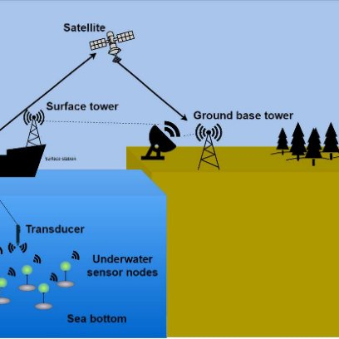

2.2.3 Protocol Design Scheme

The CEER protocol aims to extend the network's lifespan while lowering energy consumption. It makes advantage of cooperative communication, in which a number of nodes collaborate to send data. By doing this, packet loss is decreased and communication dependability is increased. Additionally, the protocol chooses effective routing paths to save energy usage. It guarantees steady communication since it can adjust to shifting underwater circumstances.

2.2.4 Energy Consumption and Network Model

Using coordinates (x, y, z), sensor nodes are positioned in a three-dimensional space in this model. A graph is used to depict the network, with communication links connecting its nodes. Every node gathers information and uses multi-hop communication to transmit it to the base station. Communication occurs within a predetermined range, and the distance between nodes is computed.

In order to assess communication quality, the model takes into account variables including signal intensity, noise, and transmission loss. Routing decisions are based on parameters such as residual energy, distance, Bit Error Rate (BER), and Signal-to-Noise Ratio (SNR). For data transmission, nodes with more energy and better signal quality are chosen to guarantee effective communication.

2.2.5 Routing Strategies

The two primary phases of the CEER protocol's routing mechanism are relay selection and candidate discovery. In the initial phase, sensor nodes communicate with neighbouring nodes about their location and energy. Additionally, sink nodes offer their position to direct data transfer.

Nodes are assessed based on their position and energy in the following step. Data is transferred from the source node to the sink node via the relay nodes, which are chosen based on suitability. This technique enhances data transmission efficiency and dependability.

Figure 2.2: Flowchart for Communication

start
Deploy sensor nodes & Sink nodes
Broadcast Hello Messages
Broadcast Hello Messages
Forward Data
Evaluate Node parameters
(Energy, Distance, BER)
Data Reaches Sink?
Retry or adjust strategy
End transmission
Update Energy Levels
Network Life time Ends?
Back to evaluate

parameters
End stimulation
The CEER protocol's communication method is depicted in the flowchart. Sensor and sink nodes are first added to the network. In order to communicate with other nodes, nodes broadcast hello messages. To choose the optimal routing path, nodes then assess factors like energy, distance, and BER.

After that, certain relay nodes transfer the data to the sink node. The process proceeds if the transmission is successful; if not, the routing method is modified. To guarantee effective network operation, nodes' energy levels are changed following each transmission.

2.2.6 Relay Node Selection

Based on signal strength and energy levels, the source node chooses the best relay node at this point. After being sent from the source node to the relay node, the data packet is forwarded to the sink node.

Both signal and noise components are used in node-to-node communication. Relay nodes assist in lowering transmission mistakes and enhancing signal quality. Relay node selection guarantees dependable and effective data delivery.

2.3 DISADVANTAGES OF EXISTING SYSTEM

In underwater wireless sensor networks, the Cooperative Energy-Efficient Routing (CEER) protocol increases communication reliability and energy efficiency, although it still has a number of drawbacks. Acoustic communication's long propagation delay is one of the main issues. Water causes sound to move more slowly, which makes data transmission more time-consuming and inappropriate for real-time applications.

The rising use of energy is another problem. Cooperative communication utilises more energy but increases dependability by involving numerous nodes in data transmission. Inadequate management of this could shorten the network's lifespan. An additional issue is energy imbalance, in which certain nodes are utilised as relay nodes more frequently than others. These nodes lose energy more quickly, which could cause an early failure and have an impact on the network.

Sensor nodes may move as a result of water currents in the extremely dynamic underwater environment. This results in frequent changes to the network architecture, which causes delays, increased packet loss, and unstable communication. The CEER approach is ineffective at managing these modifications. Additionally, the system becomes more complicated as the network grows in size, which has an impact on performance and scalability.
Errors and poor communication quality are also caused by environmental variables like noise, interference, and signal loss. Overall, while CEER enhances certain elements of communication, its shortcomings highlight the need for more sophisticated and flexible routing techniques in underwater wireless sensor networks.

2.4 PROPOSED SYSTEM

An improved routing strategy is suggested for underwater wireless sensor networks in order to address the issues with current routing techniques. Enhancing communication, conserving energy, and adapting to shifting undersea conditions are the primary goals. In order to function well even in the face of problems like latency, signal loss, and node mobility, the system makes use of intelligent routing and cooperative communication.

When choosing relay nodes, the suggested system takes into account crucial variables like energy, distance, and communication quality. This prevents overusing some nodes and aids in selecting the optimal nodes for data transfer. Consequently, the network lifetime rises and energy is used more effectively.

Additionally, the system makes use of adaptive routing, in which nodes constantly assess their neighbours and select the optimal route. By adapting to environmental changes, it improves performance and lowers packet loss. Reliability is increased by using multi-hop communication to relay data through intermediary nodes.
Sink mobility is an additional feature in which the sink node travels to various sites in order to gather data. As a result, energy consumption is balanced and the burden on neighbouring nodes is reduced. Overall, the suggested method improves underwater network performance, efficiency, and communication dependability.

2.5 ADVANTAGES OVER EXISTING SYSTEM

Comparing the suggested system to the current CEER protocol reveals a number of benefits. An important advantage is increased energy efficiency. In order to distribute energy consumption equally among all nodes, the system employs intelligent routing, which takes into account variables like energy, distance, and signal quality. This extends the lifetime of the network by preventing some nodes from rapidly depleting their energy.

An further benefit is increased communication dependability. Relay nodes are chosen by the system according to their energy and signal strength, which increases packet delivery ratio and lowers data loss. The technology makes sure that data is transmitted more accurately and efficiently by selecting better communication pathways.
Additionally, the suggested approach adjusts to evolving underwater circumstances. It constantly modifies routing paths according on the state of the network, in contrast to traditional systems.This improves network stability and dependability by managing node mobility and lowering packet loss.

By minimising unneeded retransmissions and poor communication channels, the method also lowers transmission delay. For real-time applications, this leads to quicker data transfer. Additionally, by gathering data from various locations, sink mobility helps balance the network load by lowering energy consumption in particular areas.

Long-distance signal loss reduction and increased reliability are further benefits of multi-hop communication. Overall, the suggested system outperforms current techniques in terms of performance, efficiency, and dependability, making it appropriate for practical underwater applications.

CHAPTER 3
ANALYSIS

3.1 INTRODUCTION

Because it aids in comprehending the issue and determining the optimal remedy, the analysis stage is crucial. Communication in underwater wireless sensor networks is challenging because of issues like high latency, low bandwidth, energy constraints, and water current-induced network architectural changes.
Signal quality is impacted by environmental variables including temperature and pressure, which also result in noise and data loss.

Thus, the system concentrates on lowering signal loss and enhancing communication dependability.Energy efficiency is particularly crucial because sensor nodes rely on batteries that are difficult to replace. The system investigates ways to lower energy consumption using improved routing techniques, such as multi-hop communication.

Another problem is node migration since water currents cause nodes to constantly shift positions. Intelligent techniques like Deep Q-Network (DQN) are employed to address this and improve routing choices. In general, the study aids in the development of a dependable and effective underwater communication system.

3.2 REQUIREMENT SPECIFICATIONS

Because it outlines the resources required to correctly create and implement the system, requirement definition is a crucial stage in the system development process. Finding the technology and software needed to develop, simulate, and analyse the routing system is the main goal of this project. Additionally, it guarantees that the system satisfies functional and performance criteria and assists in choosing appropriate technologies.

3.2.1 HARDWARE REQUIREMENTS

Due to the project's primary focus on simulation and algorithm development, there aren't many hardware requirements. Simulation tools and machine learning models require a typical computer system with decent processing power and enough memory to function properly. It is advised to have a PC with an Intel i5 processor or above and at least 8 GB of RAM. Software installation and data storage also require a sufficient amount of storage space.

Interaction requires a keyboard, mouse, and monitor, among other basic input and output devices. Accessing resources and downloading tools also require a reliable internet connection. While real-time deployment is not necessary, the system should be able to perform simulation jobs well.

3.2.2 SOFTWARE REQUIREMENTS

In order to design and evaluate the suggested system, software is essential. Because they facilitate machine learning and are user-friendly, programming languages like Python are utilised. Underwater networks are modelled and performance parameters like energy consumption and delay are assessed using simulation tools like NS2, NS3, or Aqua-Sim.

To use these programs, you need an operating system such as Linux or Windows. Coding and debugging are aided by development environments like PyCharm and Visual Studio Code. The DQN model is implemented using machine learning technologies like PyTorch and TensorFlow. Performance comparisons and results analysis are also done with data visualisation tools. All things considered, these software tools aid in efficiently developing, testing, and assessing the system.

3.3 CONTENT DIAGRAM OF PROJECT

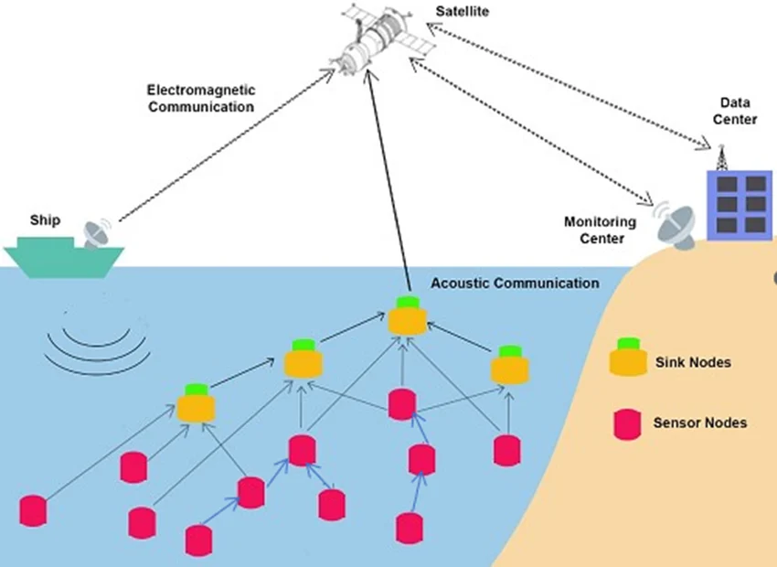

The content diagram illustrates the operation of the system and the flow of data between its components. Underwater sensor nodes that gather environmental data are where it all begins.The routing module receives this data and uses the DQN model to determine the optimal path. After that, multi-hop communication is used to send the data across several nodes.The data is then processed and used for monitoring and analysis at the base station after being sent there by the sink node.

CHAPTER 4
DESIGN

4.1 INTRODUCTION

The design phase is a crucial stage in turning concepts into a functional system. Developing a machine learning-based intelligent routing system for underwater wireless sensor networks is the primary goal. In a dynamic underwater environment, the design aims to increase packet delivery, minimise communication latency, and reduce energy usage in order to improve performance.Numerous issues affect underwater networks, including noise, signal loss, bandwidth constraints, and shifting network topology brought on by water currents. Because traditional routing techniques rely on predefined rules, they are unable to properly tackle these issues. The suggested method employs a learning-based strategy that can adjust to shifting circumstances to address this.

This approach makes use of reinforcement learning since it enables the model to learn from its surroundings. The system monitors the state of the network, acts, and gets incentives as feedback. It makes better choices and chooses better routes over time.Deep Q-Network (DQN) is utilised to boost performance even more. It handles complex data and improves decision-making by combining deep learning with reinforcement learning. The system learns more effectively and becomes more stable with the use of methods like experience replay and exploration tactics. All things considered, the design offers a clever and flexible way to effectively communicate underwater.

4.2 UML DIAGRAM
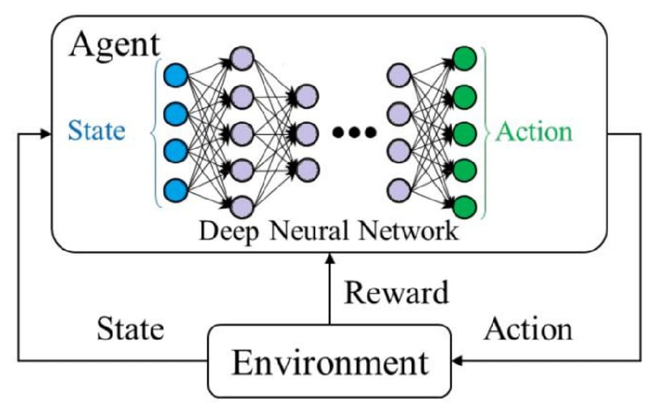
The suggested system's reinforcement learning process is depicted in the UML diagram. It describes how the agent interacts with its surroundings. The agent serves as the decision-making unit in this system, and the undersea network serves as the environment.

The agent keeps track of the network's current conditions at every stage, including communication quality, distance, and energy levels. A neural network is used to process this data, assisting the agent in selecting an action. Selecting a relay node for data transmission is represented by each operation.

The environment provides feedback in the form of a reward after the action is completed. The outcome, such as increased energy efficiency or decreased delay, demonstrates how wise the choice was. Over time, the agent gains knowledge and makes better decisions based on this input.

The system becomes more adaptable and effective as a result of this constant interaction, which also helps it make better routing decisions and adjust to changing situations.

4.3 SYSTEM ARCHITECTURE

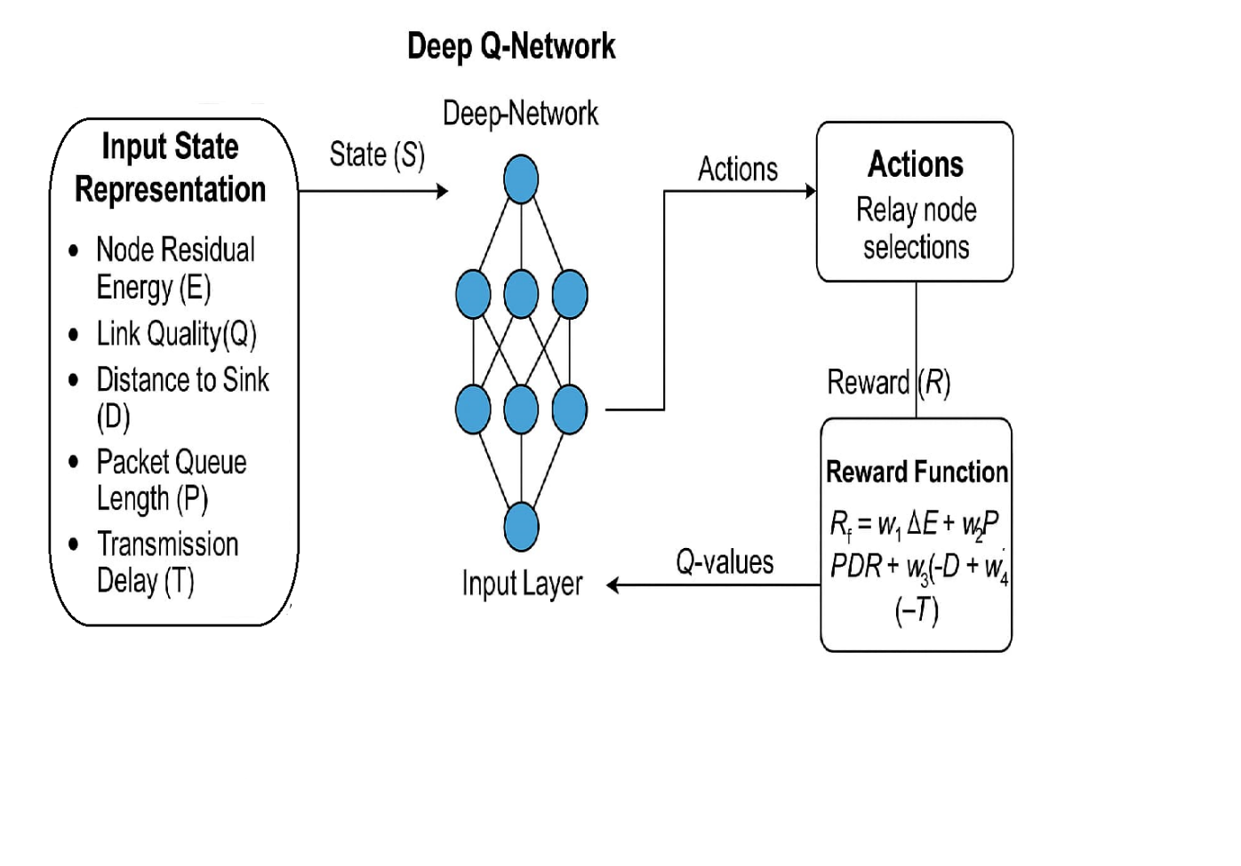

The Deep Q-Network (DQN)-based routing technique is used in the system architecture to address the difficulties of underwater communication. It is made up of various components that cooperate to enhance network performance and make smart routing decisions

The system first gathers critical network data, including energy levels, communication quality, distance, and delay. The network's present state is better understood by the system thanks to this data. After that, the data is prepared and processed so that the learning model can use it.

The neural network is the central component of the system; it evaluates the input data and determines the optimal course of action. The best relay node for data transmission is chosen by the system based on this. It employs a strategy that enables it to employ the most well-known answers as well as investigate novel possibilities.
The system gets feedback in the form of a reward based on performance metrics including packet delivery, latency, and energy consumption following each action. As a result, the system learns and gets better over time. Additionally, it keeps track of past experiences to guarantee steady learning and help in future decision-making.
All things considered, the architecture contributes to the development of an intelligent, effective, and flexible routing system for underwater wireless sensor networks.

4.4 MODULE DESIGNING AND ORGANIZATION

The system is built in a modular fashion, with each component serving a distinct purpose. This facilitates comprehension, upkeep, and improvement of the system.
The environment module replicates various situations, including node position, energy levels, and communication status, and depicts the undersea network. It offers input for the learning process and modifies the network state in response to the system's activities.

The state processing module transforms unprocessed network data into a format that the DQN model can utilise. To enable the system to make precise decisions, it organises and processes the data.

The primary component of the system that makes decisions is the DQN agent module. It chooses the optimal course of action based on the state of the network using a neural network. Over time, it enhances its performance by learning from past encounters.

The relay selection module selects the optimal node for data transmission based on the output from the DQN agent. This enhances network performance and aids in effective routing.

Each action is assessed by the reward computation module based on variables such as communication quality, energy consumption, and latency. The system gains knowledge from this input and is able to make better choices going forward.

4.5 DQN-BASED RELAY SELECTION

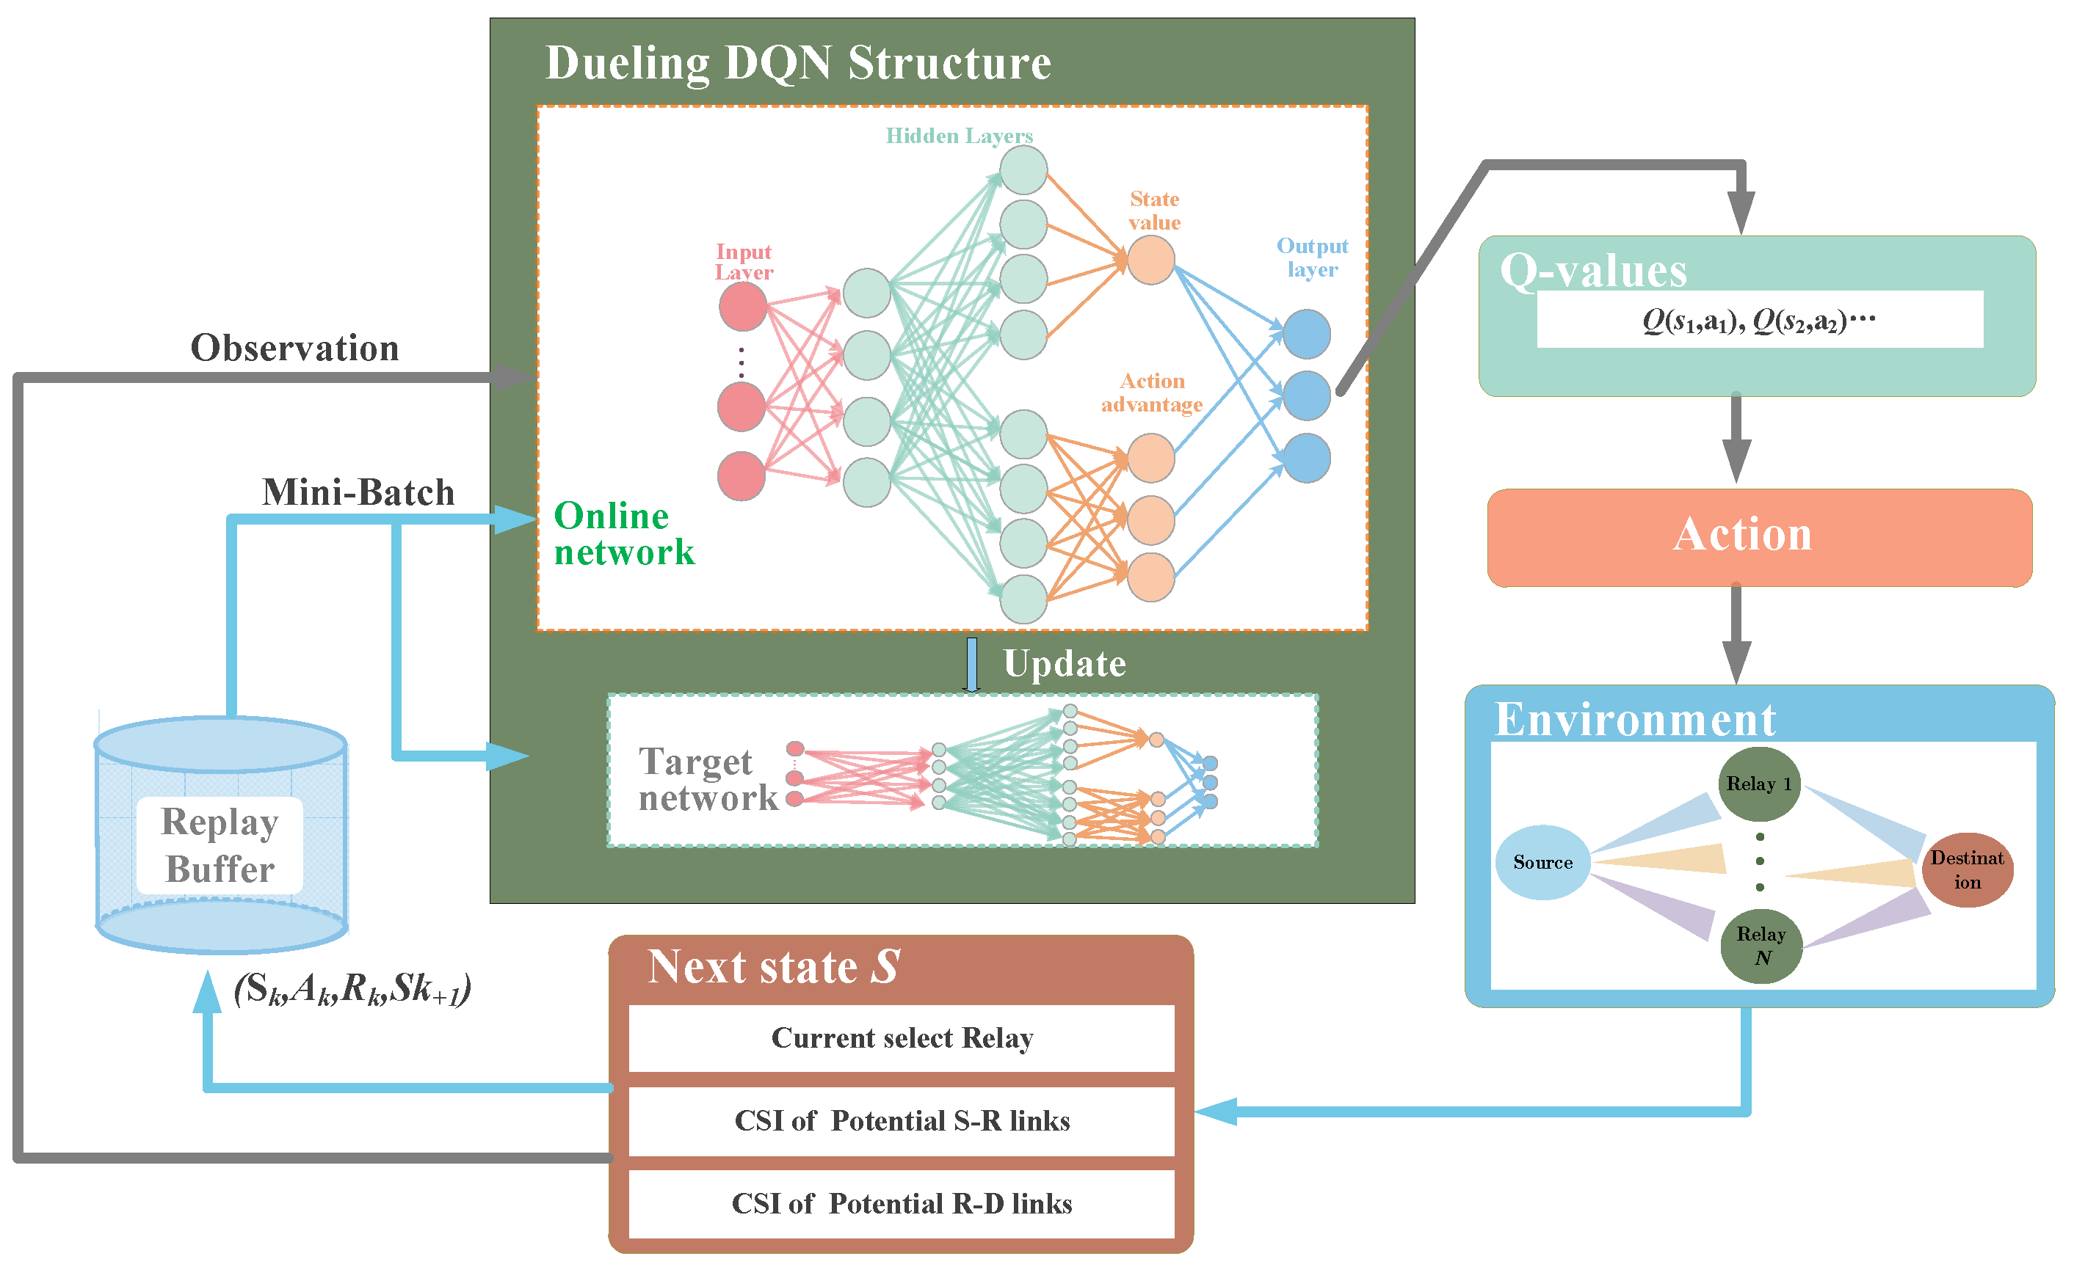

The DQN-based relay selection is the system's most crucial component. It facilitates the system's ability to learn from its prior experiences and improve its routing choices. Energy, distance, link quality, delay, and queue status are among the network-related data that the system first gathers.

The neural network receives this data and uses it to calculate values for various relay node choices. The optimal relay node is then chosen by the system using these parameters. Following the decision, the system evaluates the action's quality and provides feedback in the form of a reward.

The system modifies its choices depending on both present and future rewards as it learns. Additionally, it enhances and stabilises learning by drawing on prior experiences. Overall, this procedure aids in the system's route selection and gradually enhances network performance.

4.6 LEARNING AND OPTIMIZATION PROCESS

The suggested system has a continuous and iterative learning process. The system first investigates various actions to collect environmental data. As learning advances, it moves toward exploitation, making decisions about what to do based on what has been learnt.

The goal of the optimisation procedure is to minimise the difference between the target and forecasted Q-values. Gradient descent and backpropagation techniques are used to accomplish this. To increase performance and accuracy, the system changes its neural network on a regular basis.

The system eventually converges to an ideal routing plan thanks to the mix of exploration, exploitation, and optimisation.

4.7 SYSTEM WORKFLOW

The environment and the DQN agent communicate continuously during the system's overall workflow. The environment gives the current state, the agent chooses an action, and the environment replies with an updated state and reward.
The system can learn from this process and become more efficient by doing it several times. The workflow makes sure that effective communication is maintained while the system adjusts to shifting network conditions.

CHAPTER5
IMPLEMENTATION
AND RESULTS

5.1 INTRODUCTION

The planned system is transformed into a functional model and its functionality is evaluated during the crucial implementation phase. In this research, an underwater wireless sensor network routing system based on Deep Q-Networks (DQNs) is implemented in a simulation environment. The primary goal is to evaluate its performance against current techniques such as CEER, EELRP, and EEDORVA.
Routing is challenging in underwater environments because to its complexity and unpredictability. The best relay nodes are chosen by the system using reinforcement learning to address this. Routing decisions are made by the DQN agent, which constantly communicates with the network and monitors its state. This improves data transport dependability, lowers latency, and uses less energy. The suggested approach handles underwater communication more effectively, according to the simulation results.

5.2 IMPLEMENTATION OF KEY FUNCTIONS

The system's implementation incorporates a number of crucial features that support intelligent routing. Key network parameters, including energy, distance, delay, queue length, and communication quality, are first gathered by the system. The DQN model uses this data as input, which reflects the network's current state.
The DQN agent chooses the optimal relay node for data transfer based on this information. It employs a strategy that gradually improves performance by striking a balance between utilising the most well-known routes and attempting novel ones. In order to assess each choice based on variables like packet delivery, delay, and energy consumption, the system also employs a reward system. The model learns more effective routing techniques as a result.

5.3 METHOD OF IMPLEMENTATION

In order to implement the system, sensor nodes are positioned in a three-dimensional underwater environment using a simulation. Through a series of processes, the model is trained by watching the network, acting, and learning from the outcomes.

The neural network is trained with learning strategies that enhance accuracy and decrease mistakes. The best relay nodes are chosen by the system over time, which enhances network performance.

Ultimately, performance metrics including packet delivery ratio, transmission loss, latency, residual energy, and number of active nodes are used to assess the system. The findings demonstrate how the suggested solution enhances network performance in terms of efficiency, dependability, and general performance.

5.4 RESULT ANALYSIS AND DISCUSSION
5.4.1 Average Alive Nodes Analysis
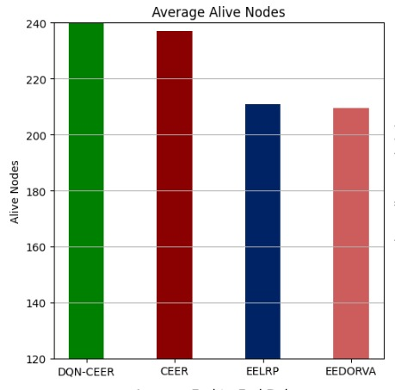

Figure 5.1: comparison of average alive nodes
between traditional methods and DQN

The average number of active nodes in various routing methods used in Underwater Wireless Sensor Networks (UWSNs) is compared in this bar graph. DQN-CEER, CEER, EELRP, and EEDORVA are the four protocols that are analysed. Since it directly relates to the lifespan of sensor nodes placed in an underwater environment, the metric of living nodes is an essential indicator of the network's longevity and energy efficiency. A protocol is more effective in controlling energy consumption, lowering node failures, and boosting the network's overall resiliency when it maintains a higher number of active nodes.

With almost 240 nodes, the DQN-CEER protocol—shown by the green bar—shows the greatest number of active nodes. This shows that DQN-CEER is the most energy-efficient protocol out of the four, effectively extending the network's sensor nodes' lifespan. Relay selection is optimised using DQN-CEER's deep reinforcement learning-based method, resulting in balanced energy usage across nodes. The protocol can dynamically adjust to shifting undersea conditions by utilising deep Q-learning, preventing abuse of specific nodes and hence lowering early node deaths.

5.4.2 End-to-End Delay Analysis
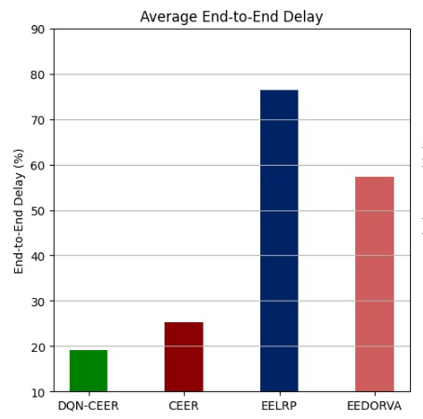

Figure 5.2: comparison of Average end-to-end delay
between traditional methods and DQN

The average end-to-end delay in several routing systems for Underwater Wireless Sensor Networks (UWSNs) is compared in this bar graph. The time it takes for data packets to go from the source node to the destination node is measured by end-to-end delay, a critical performance statistic. For real-time underwater monitoring applications including environmental sensing, tracking marine life, and catastrophe avoidance, a more effective and responsive communication network is indicated by a smaller end-to-end delay.

With an end-to-end delay of about 20%, the DQN-CEER protocol—shown by the green bar—shows the lowest. This suggests that in terms of data transfer speed, DQN-CEER is the most effective protocol. Deep Q-Networks (DQN)-powered intelligent relay selection, which dynamically optimises routing choices, is the cause of this low latency. DQN-CEER ensures quicker data delivery by reducing the number of hops needed for packet transmission by utilising reinforcement learning.
5.4.3 Transmission Loss Analysis

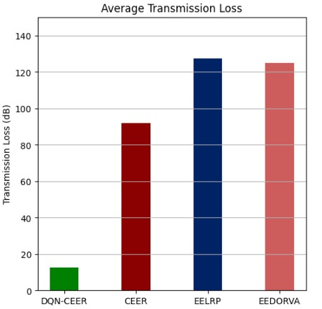

Figure 5.3: comparison of Average Transmission Loss
between traditional methods and DQN

The average transmission loss that various routing methods in Underwater Wireless Sensor Networks (UWSNs) experience is compared in this bar graph. DQN-CEER, CEER, EELRP, and EEDORVA are the four protocols under evaluation; transmission loss is expressed in decibels (dB). In UWSNs, transmission loss is a crucial performance parameter since it directly affects data delivery dependability, energy consumption, and communication efficiency. Improved communication efficiency, network stability, and signal propagation are all indicated by a lower transmission loss.

The bar chart's results unequivocally show that the most effective procedure for reducing transmission loss is DQN-CEER, which is followed by CEER, EEDORVA, and EELRP. The necessity of intelligent relay selection and optimised routing techniques in UWSNs is shown by the notable variations in transmission loss between different protocols. For long-distance underwater applications, protocols that do not optimise packet forwarding pathways suffer from increased transmission losses.

CHAPTER 6
TESTING

6.1 INTRODUCTION

Testing is a crucial stage in any system's development since it guarantees that the developed system functions properly and achieves the necessary goals. The performance, dependability, and efficiency of the suggested Deep Q-Network (DQN)-based routing protocol in Underwater Wireless Sensor Networks (UWSNs) are tested in this study. It is crucial to confirm that the system can manage changing network conditions including node mobility, signal attenuation, and energy limits because underwater settings are extremely dynamic and complicated.

6.2 LEVELS OF TESTING
To guarantee the accuracy and effectiveness of the system, testing is done at several levels. Unit testing is first used to confirm that each module—such as state representation, action selection, and reward computation—works as intended. To make sure it generates the right results for the inputs, each module is tested separately.

Integration testing is carried out to make sure that all modules function correctly after unit testing. The interaction between various system components, such as the communication between the DQN agent and the environment, is confirmed in this step. It guarantees error-free, accurate data transmission between units.
6.3 VALIDATION TESTING

To make sure the produced system satisfies the stated goals and specifications, validation testing is carried out. By contrasting the outcomes of the suggested DQN-CEER protocol with more conventional routing techniques like CEER, EELRP, and EEDORVA, validation is accomplished in this research.

These findings demonstrate that the system successfully satisfies the design objectives and operates as anticipated. The suggested DQN-based routing protocol provides a dependable and effective solution for underwater wireless sensor networks, as the validation procedure shows.

6.4 CONCLUSION

The testing stage verifies that the suggested system is resilient, dependable, and effective in managing underwater communication difficulties. The multi-level testing methodology guarantees that every component operates accurately and cooperatively. As a result, the system can be regarded as appropriate for practical underwater applications.

CHAPTER 7
CONCLUSION

7.1 CONCLUSION

In summary, the suggested Deep Q-Network (DQN)-based routing strategy significantly boosts Underwater Wireless Sensor Network performance. By using reinforcement learning, the system can make intelligent routing decisions based on current network circumstances and adjust to dynamic and unpredictable underwater settings.

Key performance indicators, including energy consumption, packet delivery ratio, end-to-end delay, and transmission loss, are efficiently optimised by the system. The DQN model continuously enhances its decision-making capacity by learning from previous events, which leads to increased network efficiency and a longer network lifetime.

The suggested DQN-CEER protocol performs better in every way when compared to conventional routing protocols like CEER, EELRP, and EEDORVA. It offers increased dependability, better energy management, and quicker data transfer. Because of this, it is an extremely efficient solution for underwater communication systems used in marine research, environmental monitoring, and crisis management.

7.2 FUTURE ENHANCEMENT

The suggested technology offers a solid basis for more underwater wireless sensor network research and development. Future improvements can concentrate on using cutting-edge machine learning techniques to increase the system's efficiency and scalability. In order to facilitate cooperation between several nodes and improve routing decisions, multi-agent reinforcement learning can be investigated.
To enable real-time deployment in underwater settings, the DQN model's computing complexity might be decreased. For this, methods like lightweight neural networks and model optimisation can be employed. The system's capacity for data collecting and monitoring can also be improved by combining it with Internet of Things (IoT) technology.

By using secure routing techniques, more study may concentrate on enhancing underwater communication security. Without requiring lengthy retraining, the model can be adjusted to various situations with the use of transfer learning and federated learning.

The suggested method is a promising option for effective and intelligent underwater communication since it has a lot of promise for future advancements and practical uses.

CHAPTER 8
REFERENCES

8.1 REFERENCES

[1] "Q Learning-Based Routing Protocol With Accelerating Convergence for Underwater Wireless Sensor Networks," IEEE Sensors Journal, vol. 24, no. 7, pp. 11562–11573, 2024; Wang, X. Shen, H. Wang, W. Xie, and H. Zhang.
[2] Natarajan, V. P., and Jayapal, S., "Improving Secure Communication Using Multipath Malicious Avoidance Routing Protocol for Underwater Sensor Networks," Scientific Reports, vol. 14, 2024.

[3] IEEE Communications Surveys & Tutorials, vol. 23, no. 1, pp. 137–160, 2021; J. Luo, Y. Chen, M. Wu, and Y. Yang, "A Survey of Routing Protocols for Underwater Wireless Sensor Networks."

[4] Berlin Hency, V., and Keerthika, A., "Reinforcement Learning-Based Energy Efficient Optimised Routing Protocol for WSN," Peer-to-Peer Networking and Applications, vol. 15, pp. 1685–1704, 2022.

[5] "Distributed Cooperative Reinforcement Learning for Wireless Sensor
Network Routing," A. Barker and M. Swany, IEEE WCNC, 2022.

[6] R. Mohammadi, Z. Shirmohammadi, and M. F. Afshar, "Cooperative Reinforcement Learning Mechanism in Clustered Energy Harvesting Wireless Sensor Networks," IEEE SCIoT, 2022.

[7] X. Geng and B. Zhang, "Deep Q-Network-Based Intelligent Routing Protocol for Underwater Acoustic Sensor Network," IEEE Sensors Journal, vol. 23, no. 4, pp. 3936–3943, 2023.

[8] "An Approach to Integrate Reinforcement Learning in Wireless Sensor Network to Evade Congestion," D. Goteti and I. Rasheed, ICSCNA, 2023.
[9] "Energy-Efficient Clustering Algorithm in Underwater Sensor Networks Based on Fuzzy C Means and Moth-Flame Optimisation Method," IEEE Access, vol. 8, pp. 97474–97484, 2020; W. Fei, B. Hexiang, L. Deyu, and W. Jianjun.

[10] "Energy-Efficient Data Transmission for Underwater Wireless Sensor Networks: A Novel Hierarchical Framework," Sensors, vol. 23, 2023, Zhang, J., Wang, X., Wang, B., Sun, W., Du, H., and Zhao, Y.

[11] Wang, Chao, Shen, Xiaohong & Wang, Haiyan & Zhang, Hongwei & Mei, Haodi (2023). "Depth Information-Based Reinforcement Learning Opportunistic Routing Protocol for Energy-Efficient Underwater Wireless Sensor Networks" 10.1109/JSEN.2023.3285751 IEEE Sensors Journal, pp. 1-1.

[12] "Underwater Wireless Sensor Network and Associated Issues," P. S. Chatterjee, M. R. Lenka, and N. K. Ray, IEEE 3rd International Conference on Smart Technologies for Power, Energy, and Control (STPEC), Bhubaneswar, India, 2023, pp. 1-6, doi: 10.1109/STPEC59253.2023.10431113.

[13] Kaveripakam S, Chinthaginjala R. "Secure data transmission and optimal path selection in underwater acoustic sensor networks: LSTM-based energy prediction." PLoS One. 2023 Sep 5;18(9):e0289306. PMID: 37669288; PMCID: PMC10479917. doi: 10.1371/journal.pone.0289306.

[14] Sreerama, Manasa & Srivastava, Shreya & Upadhyaya, Yogendra & Tripathi, Ashutosh. (2024). Underwater Communication using Wireless Sensor Network Protocols. 10.1007/978-981-99-7862-5_8.

[15] "Cooperative Energy-Efficient Routing Protocol for Underwater Wireless Sensor Networks. Sensors." 2022, 22, 6945; Ahmad, I.; Rahman, T.; Zeb, A.; Khan, I.; Othman, M.T.B.; Hamam, H.

[16] I. Ahmad et al. "Machine-Learning-Based Optimal Cooperating Node Selection for Internet of Underwater Things," in IEEE Internet of Things Journal, vol. 11, no. 12, pp. 22471-22482, June 15, 2024, doi: 10.1109/JIOT.2024.3381834.

[17] B. Jin et al., "T-D3QN: Deep Reinforcement Learning-Based Digitalising Bit Allocation for Target Tracking in Underwater Wireless Sensor Networks," IEEE Transactions on Aerospace and Electronic Systems, doi: 10.1109/TAES.2025.3546875. \
[18] A. Benarfa, S. Dahmane, and B. Brik, "A Conceptual Framework for Predictive Maintenance of Underwater Sensors Using Named Data Networking and Machine Learning," International Conference on Intelligent Computing, Communication, Networking, and

[19] Deep Q-Learning Based Adaptive MAC Protocol with Collision Avoidance and Effective Power Control for UWSNs. J. Mar. Sci. Eng. 2025, 13, 616. Rahman, W.U.; Gang, Q.; Zhou, F.; Tahir, M.; Ali, W.; Adil, M.; Khattak, M.I. Void Avoidance Opportunistic Routing Protocol for Underwater Wireless Sensor Networks

[20] Mhemed R, Comeau F, Phillips W, Aslam N. doi:/10.3390/jmse13030616. doi: 10.3390/s21061942; PMID: 33801951; PMCID: PMC8001244; Sensors (Basel). 2021 Mar 10;21(6):1942.

